FOR IMMEDIATE RELEASE - Nov. 28, 2014

Pre-ordering begins for new wireless SailTimer Wind Instrument™

Low cost, high-tech.

The SailTimer Wind Instrument™ is the only masthead anemometer in the world that can transmit directly to apps on tablets and smartphones. It is designed to work with third-party apps, and also has an accessory for plugging in to NMEA networks. See your wind angle on a wind gauge, or use the SailTimer™ app to update your optimal tacks and Tacking Time to Destination as the wind changes.

SailTimer Inc. has kept this innovative new product in stealth mode during development, but full product specifications are now available at www.SailTimerWind.com. The new wireless, solar-powered SailTimer Wind Instrument™ is now available to pre-order online for US $349.99, direct from the manufacturer (no middleman). This special discount will end in January, when the cost will rise to the retail price of US $450.

The Wind Instrument uses a distinctive new design that sets new standards (patent pending). Compared to the previous version of the company’s wireless anemometer, this next generation is smaller, yet the developers have managed to engineer it with larger solar panels and no base unit. This new design is vertical, so that it is not a horizontal perch for birds. It is small and portable, with a standard 1/4-inch tripod mount in the bottom. The wind direction arrow knows which way it is pointing, because the electronics are built right into the tail. That means no calibration is needed, and it is also suitable for rotating masts (which is probably another first). Traditional anemometers often use potentiometers which have a dead zone at the end of the rotation, and may only respond to 16 points around the compass. But this next-generation wireless anemometer gives precision wind direction using nine-axis motion sensing right in the wind direction arrow, with accelerometer, gyroscope and digital compass.

Wireless and solar-powered: the new SailTimer Wind Instrument uses Bluetooth 4, which makes it easy to install, with no wires to run down the mast. For devices that may not support Bluetooth 4, including low-cost e-readers, we also have a wifi accessory that can re-transmit the wind data to any device with a web browser and wifi. The solar panels, battery and electronics are also completely encapsulated in solid UV-resistant polyurethane, like a beautiful keepsake inside a crystal-clear paperweight. This novel design is completely submersible, which also makes this the first masthead anemometer suitable for centerboard sailboats, racing dinghies, beachable catamarans, as well as larger keelboats.

Attention to detail. Precision fit. Built to last. This innovative new design has been built with the finest craftsmanship... Solid brass, marine-grade stainless steel, a 2-jewel mechanism for free rotation with virtually no friction. Beautiful curved blades that function like a traditional cup anemometer when upright, and like a propeller to maintain equal accuracy when your boat is heeling over in the wind. The perfect orchestration of moving parts.

The tail is being molded now, although the company did not want that to delay the product specifications and pre-ordering. So they have announced a soft-launch of the new website and Wind Instrument at www.SailTimerWind.com. The official product launch will be in a few weeks, when the Owner's Manual and additional specifications and photos are released.
There is a no-questions-asked 30-day return policy for the amazing new Sailtimer Wind Instrument™. You can pre-order today. Deliveries for pre-orders begin in early March. Pre-orders will ship out in the order received.

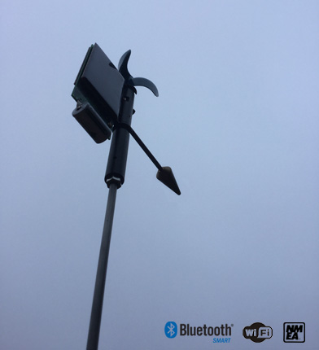

300 dpi version of above graphic available (tiff, bmp, jpg & png) at:
www.SailTimerWind.com/graphics/300dpi_SailTimerWindInstrument_softlaunch.zip (17.2 MB)

About SailTimer Inc.
The SailTimer™ brand: for sailors, a quick and easy navigation method using real-time wind data and tacking distances to display your optimal tacking route. SailTimer Inc. is the company behind the SailTimer™ app, the original SailTimer for Windows, SailTimer for Google Maps, The Sailing GPS™, the wireless, solar-powered SailTimer Wind Vane™, and the next-generation SailTimer Wind Instrument™ for boats of all sizes. We manufactured the first GPS that accounted for sailboat tacking distances (and polar plots). Out of the thousands of mobile apps available, we have the first and only app that calculates tacking distances and times, and displays your tacks as chart overlays. We also developed the first (and only) masthead anemometer that transmits to mobile devices. As another example of our innovative R&D, we developed the first-ever system for mounting a masthead anemometer without needing to lower or climb up the mast. SailTimer Inc. has a number of patent filings for the low-cost product solutions that we have been bringing to sailing enthusiasts. www.SailTimerWind.com/Corporate.html

